Lab 4

Joe Bartocci

1.

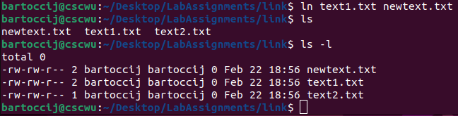

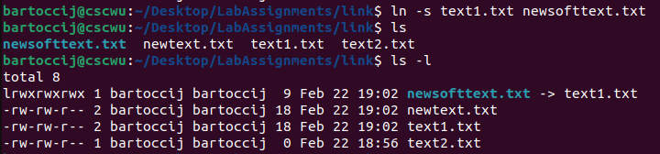

2. The following code finds the min and max value in an array of numbers by creating threads to do each of those actions individually

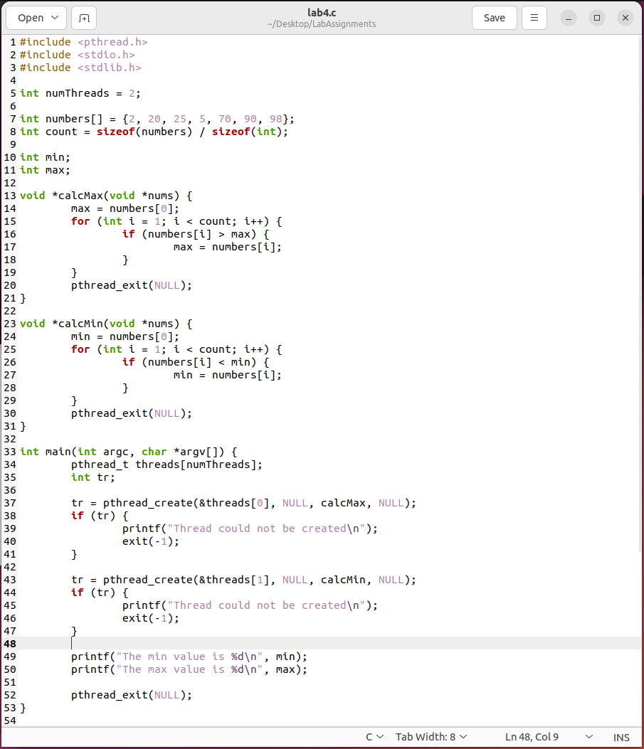



3.

